First Evangelical Lutheran Church

1206 North St. Joseph - Gonzales, Texas 78629 – 830-672-2057
Our Pastor: Reverend Ildikó Rigney

10:30am Worship Service - Communion on the 1st and 3rd Sundays of the Month
(drive through communion is from 9:30 to 10:00)
Service is live streamed on Facebook @
First Evangelical Lutheran Church

Sermon Only is on You Tube, Ildikó Rigney

Email: firstevangelicallutheran@gmail.com
Web Site: www.felcg.org
Electronic Giving: Go to Website, Click on Donate, follow the prompts.

FELC WELCA Preparing BOXES for Annual Lutheran World Relief.
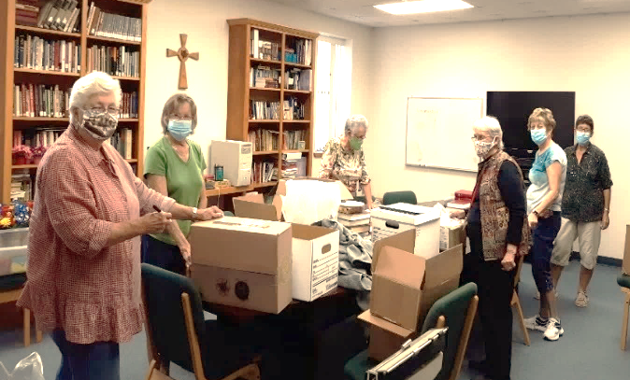
The Ingathering was originally scheduled for last spring after Easter but, due to the Pandemic, it was rescheduled for this fall.

(left to right)
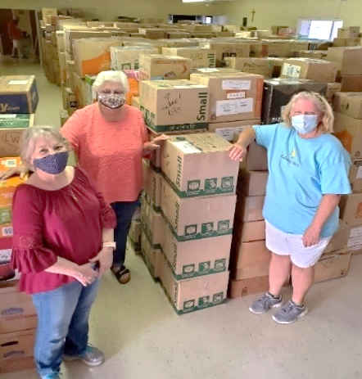
Barbara Hand, Margie Malaer, Florence Baker, Connie Kern, Sherrie White and Colleen Marek

12 School Kits, 12 Health Kits and 56 Quilts
(the quilts were lovingly prepared and donated
by Ellen Lehnert and Marjorie Malaer).

Barbara Hand and Brittany Walker delivered the boxes to
St. John Lutheran Church in Marion where they will be held
for shipping worldwide.

Thank You St. John Lutheran Church for being our drop off point.
WELCA presented the annual Thankoffering Service on Sunday, November 22. Belinda Walker prepared the beautiful table seen in the picture. Home Grown Pumpkins were provided by Briggs Hand.

This is a rich tradition of thanking God for his many blessings through giving at the Thankoffering service. It is generous giving that enables our WELCA to share with organizations of need.

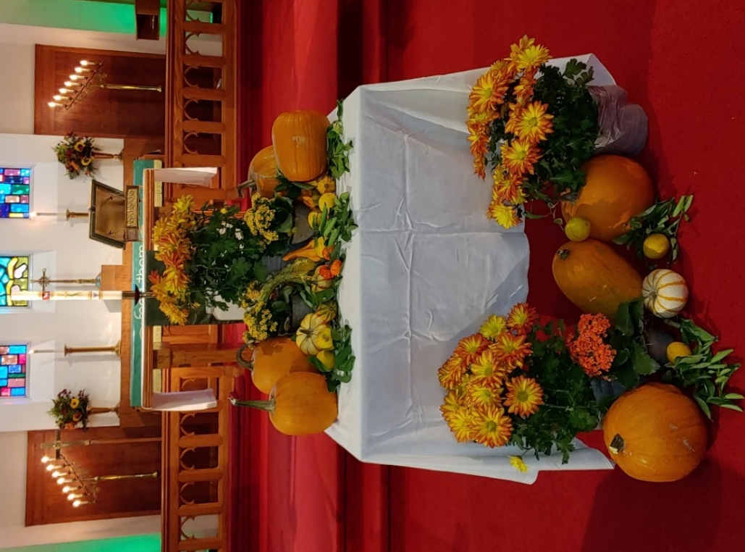

Our long honored tradition of placing Poinsettias on the Altar at Christmas Eve in honor or memory of someone special will be different this year. Our florists needed a confirmed order for 2020 Poinsettias and 2021 Easter Lilies in June. Due to the Pandemic, it was decided that we could not do that.

An alternate solution for individuals/families that wish to continue this tradition, is to purchase your own poinsettias (does not have to be from the florist, often HEB and Wal Mart has lovely plants.) The office will need information on whom you are giving the poinsettia for NO LATER THAT than Monday December 14.) The office will be open Monday, 12/21, Tuesday, 12/22 and Wednesday, 12/23 from 9:00am to 4:00pm. Poinsettias may be dropped off on one of these days. Our office will be closed on Thursday, 12/24. In addition, the office will be closed on Thursday, 12/31.
If you have questions, please call the office at 672-2057.

December 1, 2020
Meeting Highlights

The minutes of the November Council Meeting were read and accepted as read.
Pastor Ildikó presented her monthly report.
The majority of the meeting was focused on a letter from the Bishop's office regarding
the suspension of in person Church service. The letter states because of the rise in Covid 19 cases "we strongly recommend that all congregations in our synod suspend inside, in-person worship through the end of the year ". After much discussion, we believe we have all of the suggested processes in place that are suggested by the CDC
to keep everyone safe and will continue with our current in person services. We will go back to entering the church through the Baptismal door by the elevator as we did in the summer. Please pick up a bulletin and communion elements when you enter. We ask that you wear your mask during the service. At the end of the service we will usher everyone out starting from the back of the church.
Our candlelight Christmas Eve service will begin at 6:00pm and we will follow the same procedures as above. Because we can only use half of the seats in the church we
will set up for overflow in the fellowship hall.
If you are not comfortable attending in person church remember you can always watch the service on the Church Facebook Page (First Evangelical Lutheran Church). If you need any help with this please let the church secretary know and we will help.
Thank You, Nathan Neuse
Fellowship Board Chairs
Ruth Ann Campion and Linda Null

The Board extends to everyone a

Merry Christmas
and a safe and Happy New Year.

Starting December 6, Beverly Pirkle will have Sunday School Class for AGES 3-6 on the first Sunday of each month in the Fellowship Hall From 10:00am to 10:20am.

Contact Beverly with questions.
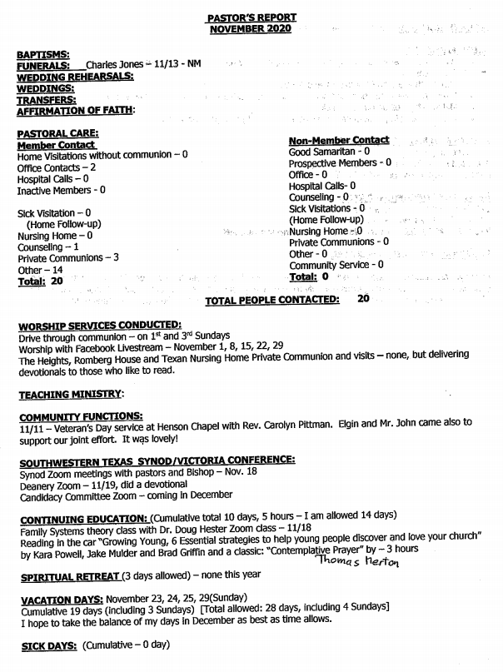

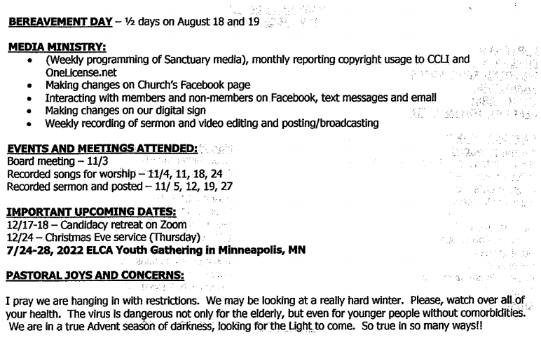
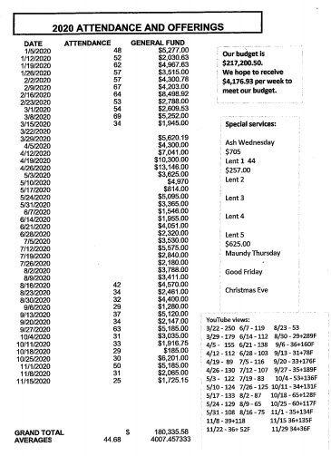

Please notify Jeanie Noack of any change.
December Ruth Ann Campion & Linda Null
January Marilyn Krum & Betty Nowotny
February Robin White & Sherrie White

Lay Assistants to the Pastor

December Paul Watkins
January Beverly Pirkle
February Darrell Haug

Please refer to Harold Grauke with any questions or changes.

December Richard Krum, Michael Kuck, Nathan Neuse
January Connie Kern, Marjorie Malaer, Madelynn Brown
February Emmet Baker, Jr., Ronald R. Baker, Brent Baker

Sunday School Offerings Used to Purchase ELCA Good Gifts
As members of the Evangelical Lutheran Church in America (ELCA), we believe that
God is calling us into the world – together. And with generous, loving hands, we can
make a difference. ELCA Good Gifts is your opportunity to provide critical support to
the ministries and programs that mean the most to you and the people you love.

Adult, Children And Youth Sunday School Donations of $100 was used to purchase
these animals through ELCA Good Gifts to be given to families in need.
1. 2. 3.

1.With this gift — a combination of two of our most popular gifts — a family gains access to
an ongoing supply of eggs from their chickens and protein-packed milk from their goat.
Even better, extra eggs and dairy products can be sold at the market for a steady income.

2. More Chicks… When chicks grow up to become chickens, their eggs not only provide an
ongoing supply of protein-rich meals — they can also help start a small business and
generate a steady source of income.

3.This little piggy couldn’t be a bigger lifesaver. This gift is a source of natural fertilizer that
helps crops grow tall and strong, and can also be sold at the market for extra income
when it is needed.

December January February
Ildiko Rigney 12/01 Sara Schmidt 01/01 Dorothy Sutton 02/01
William Komoll 12/02 David Tieken 01/09 Kendall Fougerat 02/03
Leslie Buesing 12/04 Elgin Heinemeyer 01/11 Wayne Hillman 02/03
Bryce Danz 12/06/18 Connie Komoll 01/11 Cody Oakes 02/07
Tyley Bouler 12/11/14 Keith Schmidt 01/13 Madison Pirkle 02/07
Katalin Szanto 12/15 Justin Campion 01/14 Linda Null 02/10
Sherry Davis 12/17 Wesley Caldwell 01/19 Brian Buesing 02/11
Connie Kern 12/19 Cain Wyatt 01/27 Anna Rigney 02/11
Rowdy Hanscheck 12/20/ Darrell Haug 01/28 Richard White 02/13
Ronald R. Baker 12/25 Lynn Meredith 01/29 Hagen Brown 02/15
Tammy Hillman 12/27 Kelsey Bouler 01/30 Kevin Oakes 02/15
Ruby Berger 12/28 Le Ann Wolff 02/16
John Campion 12/30/16 Madelynn Brown 02/17
Beverly Wegener 02/17
Tinker Brown 02/18
Brent Baker 02/20
Barbara Hand 02/21
Don Vlasak 02/22
Richard Krum 02/23
Brent White 02/23
December Carl Zella 02/23
Erlene & John Zavadil 12/17 23 years Kelli Soefje 02/24
Judy & Emmet Baker 12/19 33 years
Billie Jo and Bruce Tieken 12/28 35 years

January
Nathan & Marilyn Neuse 01/01 36 years
Harold & Brenda Grauke 01/18 52 years

No Anniversaries in February

Please notify the office at 672-2057 if a special date for you or your family is incorrect or not listed.

Bereaved Family and Friends of: Iboja Felger (Rigney) 11/20

Johnnie Joe Luna (Mary Vera-Whalley brother)11/20
Recent Prayer Requests:
Levi Rosen (health) (Rigney) 11/20 Tonja Gray (knee surgery) 11/20
Robert Matias (heart problems) Whites, 11/20 Morgan Wright (surgery 11/30, Watkins DIL )
Pete Maierhofer (throat Cancer, Cain Wyatt’s brother) The Wrights (Watkins)11/20
Tracy Pflieger (surgery) (Pastor) Donna HIsey (health) 11/29/20
Olivia Routte (child with tumor in the brain stem)

Lisa Maldonado (Mary Jane’s niece – cancer)

Requests for Healing / Health Issues/Other:
Alex Herd (19 years old, diabetes) 11/20 Joe and Mary Matejcek
Angeline Pekar (Ruby’s sister and Jeanie’s SIL) Katalin Szanto (health)
Bernice Heldarson (Jeanie’s sister) Katrina Lambrecht (Dementia, Seguin Nursing Home)
Betty Nowotny (health) Ken Schuett (health, Billie Jo’s Dad)
Callie Mae Haug Linda Moore (cancer) B. Hand 4/2019
Charlotte Neuse (health) 4/2020 Linda Null (health)
Connie Avant (cancer) 11/2020 Maple Remschel (health)

Crystal Lentz Davis (health) 4/2020 Mark & Mary Watkins
Dora Soefje (Home) Martie Frederick (cancer) (Grace & Paul)
Emily Hunt (heart failure) Paula White (cancer) 11/2019
Fletcher & Dian Garner (08/2020) Rosie Crieder (health, M. Pirkle’s Grandmother)
Florene Braune (health, 4/5/20) Ruby Kelley (recovery from surgery)
Gerund Blundell (Health) 4/7/20 Sherry Metting (health)
Gladys Campion (Home) Tripp Gattuso (health) (11/20)
Greg Porter & family (ALS, relative of S. Wolff family) Teresa Miller (recovery from surgery) (Ruth Ann)
Jared Cook (Grandson of Ronald R. & Sandra Baker) Zachary Charanza (Linda & Ruth Ann’s g-nephew)
Remember to pray for our Church Family & Friends:

Home: Florene Braune Dorothy Brand Sherry Metting

The Romberg House The Texan
Mabel Gray Guy Moore
Don Cain
Gerald Tieken
The Heights Carl Zella
Evelyn Kocian
Rev. Don Vlasak January Expectant Parents:
Barbara Wiedner Mikayla & Coy Condel

“When it’s really dark, that’s when you can see the stars”…claimed both Ralph Waldo Emerson and Martin Luther King, Jr.
We are at the time of the year, when it literally becomes true, as we approach the longest night in the year. Come 5 o’clock we are in dusk and ready for the cloak of night.
We are also at the very end of 2020, which for so many reasons has felt like the year of darkness. You know all the reasons for that, I don’t need to elaborate.
Throughout history there have been many eras where the convergence of events brought about similar times. The time of Christ’s birth was one, as well, for the Jewish people living under foreign occupation.
Jesus Christ comes to bring light into the darkness of the world and the darkness of the soul. When things are most desperate we recognize His light best, I believe, and we long for His second coming with most anticipation.
This Christmas may be a very hard one for many, but I want to remind you that it is exactly for times like this that our Lord Jesus came among us, to remind us that we are never alone, and that the Light always shines, even if it is just one candle somewhere in the corner.

Allow yourself to notice the light. Allow yourself to notice Jesus even during a time like this. Plug into His light and His strength. And if we can help you with that, please let us. Christmas may look different this year, but we will celebrate His coming on December 24 at 6pm in our church. Behind masks, with electric candles, spaced out and probably with a lot less attendance than usual, but we will be there humming or singing “Silent Night”. If you can, come or tune in via Facebook Live. Read Luke 2. Turn on the lights on your Christmas tree. Remember your faith and look into the future that God is preparing. The new things only He knows about, but that we hope and dream about. Keep dreaming, hoping and praying, because God will never disappoint, and His Son, our Light is here among us.
In Christ, Pastor Ildikó

First Evangelical Lutheran Church
1206 North St. Joseph Street
Gonzales, Texas 78629
830-672-2057

