First Evangelical Lutheran Church

1206 North St. Joseph - Gonzales, Texas 78629 – 830-672-2057
Our Pastor: Reverend Ildikó Rigney

10:30am Worship Service - Communion on the 1st and 3rd Sundays of the Month
(drive through communion is from 9:30am to 10:00am)

To Madelynn, Madison and Kelli!
I remember what a life-changing time it is to transition from High school to college. Horizons open. Adulthood is yours. Many questions, and among them: “Can I do this?” The final cutting of apron strings, although you still connect with your family. That knot in your throat during graduation, and as you say your farewell to family and they drive home…The endless opportunities and dreams ahead of you…
As we watch you take your final steps this May, know that we love you, support you, pray for you. We hope you take us with you in your heart, in your memories, and that you will come home to us often to tell us stories of your growth.
We love you,
Pastor Ildikó and your First Lutheran family

May 4, 2021 Meeting Highlights

Meeting minutes from the council meeting held on April 6th, 2021 were read and accepted as corrected.
Pastor Ildiko' presented her monthly report. Pastor is working on a weekday Bible Study. Stay tuned for more updates.
The Christian Education Board reported that Vacation Bible School will be held
July 12th - 15th in partnership with the Episcopal Church and Presbyterian
Church (Presbyterian Church will be hosting).
Plans are being finalized for the High School Senior recognition and Congregational Meal & Fellowship on May 23rd. I hope everyone will be able to attend. This will be
a catered meal. In order that we plan accordingly, we need to know if you plan to attend. Please; call Peggy at the church, 830-672-2057 by May 15th.
The Parish Fellowship board reminded us that the annual church picnic is scheduled for the second Sunday in September (9/12) at the Disciples Conference Center. Please put this date on your calendar and make plans to attend.
In Old Business, we have completed the agreement document with Legacy Youth Ranch for the use of 2 rooms in the education wing of the church. Legacy Youth Ranch will reimburse the church for utilities. The locks on the building have been modified so that proper security is maintained for both the Church and Legacy
Youth Ranch.
We are planning a congregational meeting following Worship Service on
June 13th. At that meeting, we will be electing members to the Parish Planning Committee (Church Council). Your participation in the future of our church is needed. If you would like to serve on a committee or would like to help on the nominating committee, please contact me at 713-582-0750.
In New Business, a discussion was held regarding a document published on the ELCA website titled:
“HOW STRATEGIC AND AUTHENTIC IS OUR DIVERSITY:
A Call for Confession, Reflection, and Healing Action.
I ask everyone to go to ELCA.org and review this document.
Thanks,
Nathan

Mrs. Beverly Pirkle will have Sunday School Class for AGES 3-6 on the first Sunday of each month in the Fellowship Hall From 10:00am to 10:20am.

We Hope to See You there.

May Jeanie Noack & Need a Volunteer
June Billie Jo Tieken & Sherry Davis
July Sara Schmidt & Need a Volunteer
Aug Barbara Hand & Marilyn Neuse
Sept Need Volunteers
Oct Belinda Walker & Need a Volunteer
Nov Ruth Ann Campion & Need a Volunteer
Dec Shirley Wolff & Beverly Wegener

Please notify Jeanie Noack of any change.

Lay Assistants to the Pastor
Please notify Pastor if there is a change
May Elgin Heinemeyer
June Richard Krum
July Karen Fougerat
Aug Paul Watkins
Sep Richard White
Oct Florence Baker
Nov Barbara Kuck
Dec Paul Watkins

Please notify Harold Grauke with questions or change.

May Brian Buesing, Hagen Brown, Walter Marek
June Connie Kern, Marjorie Malaer
July Richard Krum, Michael Kuck, Nathan Neuse
Aug Emmet Baker, Ronald Baker, Brent Baker
Sept Bruce Tieken, Stephen Pirkle
Oct Harold Grauke, Matt Wolff, Corben Wolff
Nov Brian Buesing, Hagen Brown, Walter Marek
Dec Richard Krum, Michael Kuck, Nathan Neuse

May Date # Years
Wayne & Tammy Hillman 4 36
Carlos & Ildiko Rigney 17 27
Matt & Le Ann Wolff 20 26
Brian & Leslie Buesing 27 20

June Date # Years
Darrell & Gloria Haug 10 43
Kenneth & Sherry Davis 13 23
Kenneth & Karen Fougerat 15 36
Brent & Robin White 21 13
Wesley & Brenda Caldwell 22 26
Wayne & Cain Wyatt 24 26
William & Connie Komoll 25 33
Blake & Elizabeth Mikesh 27 6
Dale & Shirley Carleton 29 19

July Date # Years
Richard & Marilyn Krum 6 30
Richard & Sherrie White 7 48
Ronnie & Shari Tate 18 40
Robert & Sandra Wolff 20 58
Kevin & Carol Oakes 30 27
Barry & Carol Wiley 31 56

August Date # Years
Paul & Grace Watkins 1 34
Ron & Sandra Baker 13 49
Keith & Sara Schmidt 14 39
Kelsey & Tyson Bouler 17 8
Steve & Beverly Pirkle 25 60

May  Mallorie Pirkle 5/01  Walter Marek 5/02  Beverly Pirkle 5/02  Mabel Gray 05/03  Karen Fougerat 05/06  Bradley Danz 05/15  James Wolf 05/16  Bruce Tieken 05/19  Carol Wiley 05/20  Gladys Campion 05/29  Billie Jo Tieken 05/29  Barbara Kuck 05/30 | July  Matthew Wolff 07/07  Kaily Hillman 07/08  Harold Grauke 07/11  Betty Tieken 07/01n  Robert Wolff 07/12  Kimberlee Brown 07/16  Penny Lee 07/19  Brady Oakes 07/26  Imogene Rainey 07/26  Ashley Tieken 07/28

June  Herb Karnau 06/01  Robin White 06/01  Corben Wolff 06/02  Rebecca Hanscheck 06/04  Brody Danz 06/06  Brittany Walker 06/09  Brenda Caldwell 06/10  John Zavadil 06/10  Justin Komoll 06/14  Carol Karnau 06/15  Joel Meador 06/16  Nathan Neuse 06/18  Melynda Davis 06/23  Gloria Haug 06/25  Shari Tate 06/26  Steve Pirkle 06/29 | August  Elizabeth Mikesh 08/04  Belinda Walker 08/06  Jason Campion 08/08  Florene Braune 08/09  Holly Danz 08/13  Bre Wolff 08/16  Katy Marek 08/18  Carlos Rigney 08/19  Susan Ainsworth 08/20  Erlene Zavadil 08/20  Jeanie Noack 08/21  Barry Wiley 08/21  Kamii Ramos 08/22  Wayne Wyatt 08/24  Adrian Buesing 08/27  James Lehnert 08/30 | August

When we pray, we are humbling ourselves before God and saying,
“I need Your presence and Your power, Lord. I can’t do this without You.”
When we do not pray, it’s like saying we have no need of anything outside of ourselves. Praying in the name of Jesus gives us authority over the enemy and proves we have faith in God to do what what His Word promises.
Christian Connections by Dayspring.

Bereaved Family & Friends of:
Jerry Oakes
Don Cain
Juanda White (R. White’s family)
Anelle Shipman (R. White’s family)

Alvin (Buddy) Noack, Jr.

Recent Prayer Requests
Florence Baker Bob Davis
Ray Soefje Nancy Stobaugh

Please Continue to Pray for:
Bruce Baker Bruce Spain (Robin White’s Dad)
Dr. Gary Heximer Gloria Muehlbrad (Grace’s Mom) (recovering knee replacement 3/8)
Greg Porter & fam (ALS, S. Wolff Family) Maple Remschel (health)
Jarred Cook (Grandson of Ronald & Sandra Baker)
Shari & Ken Schuett (Billie Jo’s parents) Rhett Meredith
Mary Jane Vera-Whalley Kevin Noack
Mark & Mary Watkins Misti Cubit
Ricky Campion Wayne White (Richards Uncle)
Zachary Charanza (Ruth Ann’s nephew)

@ Home Florene Braune Sherry Metting

@ Romberg House Mabel Gray, 210 Qualls, Gonzales

@ The Heights 701 N. Sarah DeWitt, Gonzales
Evelyn Kocian Pastor Don Vlasak
Barbara Wiedner Bertha Cuevelier

@ The Texan 3423 Moulton Road, Gonzales
Guy Moore Carl Zella

On Sunday, May 23, First Evangelical Lutheran
Church will be honoring our Graduating High
School seniors at the Worship Service and will be hosting a “Catered Meal” following the Service.
All Are Invited.

The deadline for reservations for the meal is May 15 (672-2057).

Our Seniors this year are:
Madelynn Brown Madison Pirkle Kelli Soefje

Please consider donating gently worn shoes, boots, footwear to the:

Gonzales Noon Lions Soles 4 Souls Endeavor

Shoes collected will be distributed to People in Countries of Need.We have collection boxes at the
First Evangelical Lutheran Church Fellowship Hall & in the Sanctuary. Other collection boxes are located in schools and local businesses.

Our FELC members Darrell Haug & Elgin Heinemeyer thank each of you that have donated so far. The deadline for this campaign is May 30, 2021.

2021 Flower Chart Sign Up
The following dates are open to place flowers on the altar.

May June
16 30 06

July August
18 25 1 08 29

September October
12 Picnic ? – No Flowers 3 17 24
19 26

November December
7 All Saints Day (White Flowers) 5 Advent-No Flowers

14 21 12 Advent-No Flowers
28 Advent 1 – No Flowers 19 Advent-No Flowers
24 & 26 (Poinsettias)

First Lutheran Church Family,
Thank You All for making Administrative Assistant Day
So special for me.
Peggy
.

A Great Big Thank You to the Many Volunteers in our Church. Often, you may not get the THANKS or Recognition you deserve.

Bless All of YOU
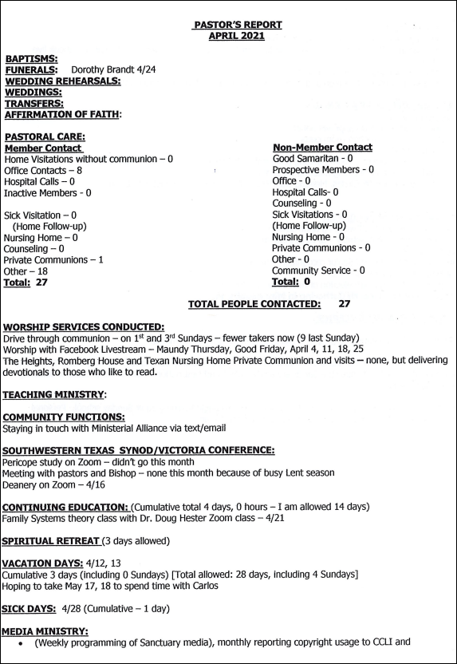

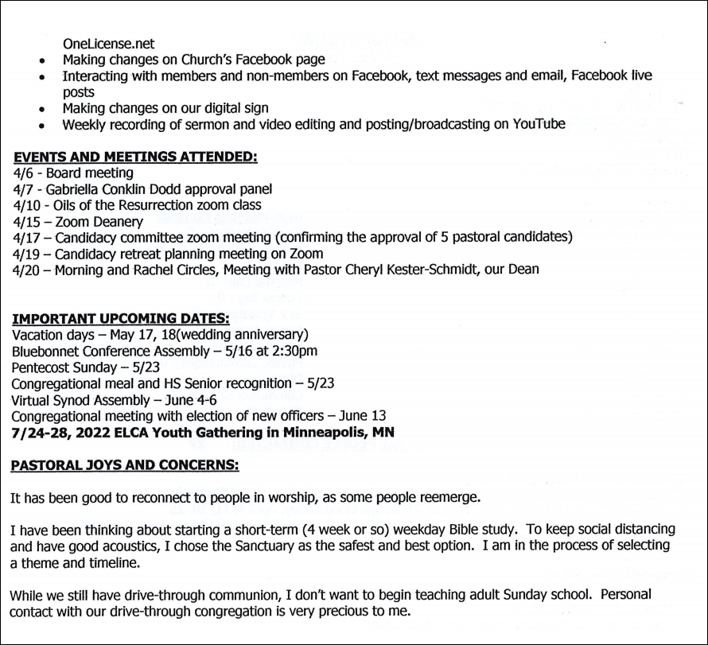

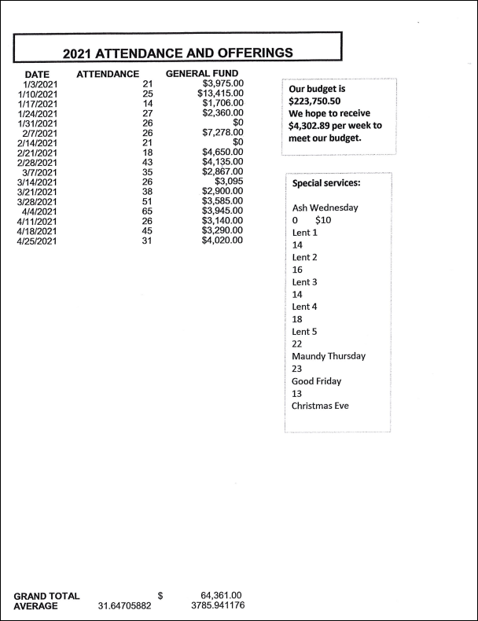

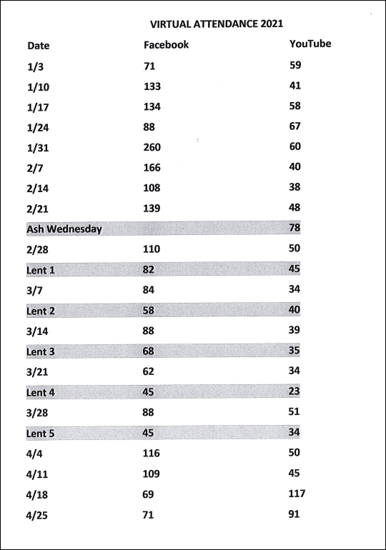

Our Service is live streamed on Facebook @
First Evangelical Lutheran Church

Sermon Only is on You Tube, Ildikó Rigney

Email: firstevangelicallutheran@gmail.com
Web Site: www.felcg.org
Electronic Giving: Go to Website, Click on Donate, follow the prompts.

If you need assistance: Contact the office @ 672-2057

A Little Humor……..

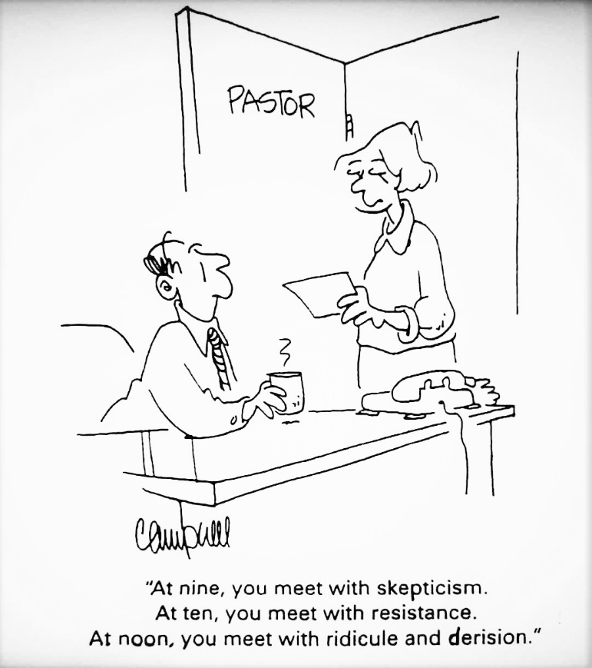

And…. How Was Your Week ?

GOD’S BLESSINGS TO EACH OF YOU AS WE CELEBRATE
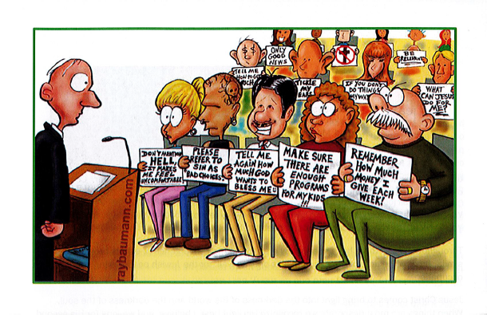
MAY 9 JUNE 20

First Evangelical Lutheran Church
1206 North St. Joseph Street
Gonzales, Texas 78629
830-672-2057

